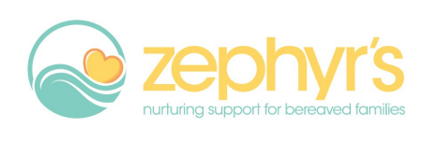

Trustees are responsible for controlling the management, administration and strategic direction of Zephyr’s, a growing charity looking to develop a strong leadership team to take us to the next level.

Main responsibilities:

* Ensure Zephyr’s is carrying out its purposes for the public benefit including actively contribute to setting the strategic direction
* Comply with Zephyr’s governing document and the law
* Act in Zephyr's best interests
* Manage Zephyr’s resources responsibly including monitoring the financial position and clear lines of accountability for financial management
* Act with reasonable care and skill
* Ensure Zephyr’s is accountable
* Take responsibility for own learning and development
* Confidentiality of sensitive and confidential information is maintained
* Act as an advocate for Zephyr’s

A Zephyr’s trustee is someone who:

* Is Enthusiastic
* Is Innovative
* Is Reliable
* Is able to support and offer strong leadership and management
* Is confident making difficult decisions about potentially uncomfortable or emotion subjects
* Is able to multi-task and make a strong contribution to the Board by being able to share and implement energy, knowledge, expertise and life experiences
* Is willing and able to actively contribute to all discussions
* Has Good numeracy skills and the ability to understand Zephyr’s financial accounts
* Will accept and understand the responsibilities and liabilities as a trustee and employer
* Will act in the best interests of Zephyr’s at all times

Estimated time commitment of two meetings per quarter, usually in the evening, and flexible in providing additional support hours as required.

Trustees must be aged 18+.

Eligible to work in the UK even though this is a volunteer role.

Location independent but within reasonable travelling distance of Nottingham.