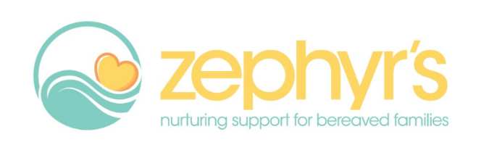

**Supporting parents following a pregnancy loss and when a baby dies**

The provision of high-quality support and care for families following a pregnancy loss and when a baby dies is vitally important. This two-hour training, facilitated by Zephyr’s and led by Paula Abramson from Bereavement Training International, is designed to help you feel better prepared and more confident to care for and support parents, at a time when they need it most.

**When is it?**  Tuesday 28th March, 2-4pm

**Where is it?** Online using Zoom - a link will be shared with attendees

**The session will cover**

* Up to date statistics, research, protocols and pathways around baby loss
* Working with families from different faiths and cultures
* Communicating sensitively - including the parents lived experience
* Self cafe and well-being
* How to relate theories of grief to your practice
* Offering support in the next pregnancy
* Information about support organisations and resources available

**Attending this training workshop will**

* Help you feel better prepared to provide good bereavement support to parents
* Provide knowledge and insights to help improve your confidence
* Ensure you are equipped with the relevant skills and information to best support parents

**How to book your place**

Places are limited and we are expecting a high level of interest.   
To secure your place please email [contact@zephyrsnottingham.org.uk](mailto:contact@zephyrsnottingham.org.uk)

<https://www.zephyrsnottingham.org.uk/>

07915 995532

42 Sneinton Market, Freckingham Street, Nottingham NG1 1DQ